Chlorhexidine Bathing for Patients1,2

A hand holding a magnifying glass with bacteria

 Bacteria in your skin, wounds, or your gut can infect your IV line. These germs are microscopic and invisible to the naked eye. Bacteria can spread by skin-to-skin contact between people, breaks in the skin such as cuts or scrapes, touching dirty items, being in crowds, and poor hygiene. Bacteria can also spread if you touch objects that has touched someone else’s skin. Bacteria often live in wounds, so keep your wounds covered with bandages. This guide will help you clean your skin of bacteria that could infect your IV line.

A person washing their hands under a running water faucet
 Good hygiene, especially regular hand washing and regular bathing, is the best way to prevent an IV line infection. Soap and water, as well as alcohol-based hand sanitizers, kill bacteria. Keep your hands clean by washing regularly with soap and water or a hand sanitizer. Take showers or baths with soap.

If your hands look dirty or you’ve just used the bathroom, you must use soap and water. Wash your hands with soap and water for at least 20 seconds. Sing the “Happy Birthday” song twice to help you wash your hands for 20 seconds. Use your own clean hand towel to dry your hands, or use paper towels.

A person using a hand sanitizer

 If your hands do not look dirty, and you have not just used the bathroom, you can use soap and water or hand sanitizer. Hand sanitizers should have at least 60% alcohol. Use enough to cover every part of your hands. Apply hand sanitizer to every part of your hands and rub together, getting between the fingers and thumb, and around the nails. Continue to rub your hands together until dry, about 20 seconds. Allow your hands to air dry. Do not wipe or shake your hands.

An icon of hands washing
 

Always wash your hands:

* Before preparing food, eating, or drinking.
* After coughing, sneezing, or blowing your nose.
* Before and after touching your eyes, nose, mouth, or genitals.
* Before and after touching any cuts or wounds, including sores, acne, boils, or rashes.
* Before and after changing bandages.
* After going to the bathroom.
* After touching urine, feces (poop), and body fluids. This includes items soiled with body fluids, such as bedding or clothes.
* After cleaning the bathroom, changing your bedding, and doing laundry.
* After touching things other people touch, such as door knobs, shopping carts, gym or rehab equipment.

**Cleaning Surfaces and Personal Items**

A person cleaning a table
 Cleaning shared surfaces is important. If you share medical equipment or gym equipment, disinfect the equipment before and after you use it. Do not share towels, washcloths, razors, or other personal items. Clean bathrooms and countertops daily with household cleaners such as disinfectants or bleach. Look for something with the word “disinfectant” or “bleach.”1 Follow the directions on the disinfectant’s label. Focus on surfaces that people touch every day, such as light switches, doorknobs, phones, toilets, sinks, and kitchen counters. Wipe with a disinfectant wipe, spray the surface with a disinfectant and let it dry, or spray the surface with a disinfectant and spread the disinfectant with a paper towel. You do not need to focus on large surfaces such as floors and walls.

A person putting clothes into a washing machine
 Wash your sheets, washcloths, and towels at least once a week. Change your clothes daily and wash them before wearing again. Keep clean and dirty laundry separate. Hold dirty laundry away from yourself to prevent bacteria from getting on your clothes. If the laundry has bodily fluids on them, wash them immediately, or place them into a plastic bag until they can be washed. Wash everything in water as hot as the fabric allows. Use color-safe bleach if your clothes allow it, but laundry detergent also works well to kill bacteria. Dry all laundry in a hot dryer and make sure laundry is completely dry before folding it.

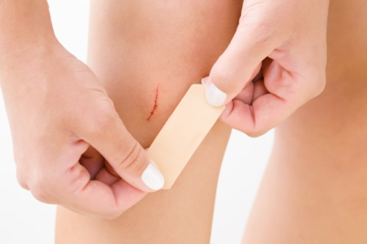**Caring for Wounds**

If you get a cut or scrape, clean it with soap and water and cover it with a bandage until it heals. Keep any infected wounds covered with a bandage. Clean your hands immediately after putting on or changing bandages. Wear clothes that keep bandages and wounds covered. Do not touch wounds. If you do touch a wound, wash your hands right away. Those helping to care for you and those in your household should also wash their hands frequently, especially when changing bandages or touching a wound. Bathe immediately after physical therapy sessions or exercise.

**Reducing the Bacteria on your Body**

You will use a special soap to reduce the bacteria on your body. This soap is commonly used in hospitals to reduce bacteria on patients. Chlorhexidine soap reduces the bacteria on your skin.

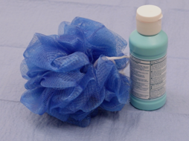

Do not use chlorhexidine if you are allergic to dye. Do not get chlorhexidine in your eyes or ear canals. If chlorhexidine does get into your eyes, flush with water.

*Every other week*, bathe every day with chlorhexidine soap for five days in a row; for example, Monday through Friday:

If you forget to shower or bathe with chlorhexidine for a single day, restart the chlorhexidine protocol as soon as possible until you have used it for a total of 5 days, not counting the skipped day. If you skip more than one day’s worth of chlorhexidine bathing, restart the 5 days of therapy.

Chlorhexidine soap:

You will use chlorhexidine soap in the shower *instead* of regular soap and shampoo. Other soaps, shampoos, lotions, or sunscreens can make chlorhexidine less effective. In the five day period when you are using chlorhexidine, do not use other soaps or shampoos after the chlorhexidine with the exception of hand soap. You can use shampoo prior to using chlorhexidine. You can use hair conditioner, shaving cream, deodorant, hair gel, and hair wax. Many lotions also make chlorhexidine less effective. If you want to use lotion, use Cetaphil Moisturizing Lotion or Eucerin Original Lotion. Do not use perfume or cologne. Sunscreen can also inactivate chlorhexidine, so be careful to not use sunscreen right after using chlorhexidine.

A group of brown spots on a white cloth
 Chlorhexidine is safe on rashes and bruises. It is also safe to use on small shallow wounds. Chlorhexidine is safe to use on surgical incisions including staples or stitches. Do not use chlorhexidine on deep open wounds.

Do not put the chlorhexidine directly on surfaces or linens that you will wash with bleach, as a brown stain will appear if chlorhexidine contacts bleach.

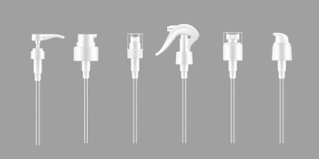

If you develop a rash or skin irritation, stop using the chlorhexidine and contact your medical provider.

***Use chlorhexidine soap that has a pump. Every time you use chlorhexidine, use a new baby wipe or a clean loofah. You can also use a clean washcloth, but it may cause a brown stain if you use bleach***.

1. Wet your face and hair with water.
2. With your head and hair out of the water stream, pump chlorhexidine onto your hands and massage it onto your face, hair, and scalp. Avoid your eyes and ears.
3. Rinse your face and hair with water.
4. If you want, you can use hair conditioner at this point.
5. Wet the loofah, baby wipe, or washcloth.
6. Use three pumps of chlorhexidine on the wet loofah, baby wipe, or washcloth and rub it into a lather.
7. Turn off the shower water. Chlorhexidine needs to be on your body for two minutes to kill bacteria.
8. 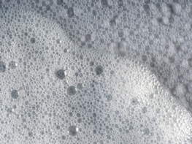Firmly massage the soapy chlorhexidine onto your skin. Get soap between all skin folds.
   * Start with your IV line. Clean the skin around the IV line. Wipe the outside of the IV line and the hub with chlorhexidine.
   * Wash your neck.
   * Wash your arms and legs one at a time.
   * Then wash your chest and back. Women should wash under the breasts.
   * Then wash your abdomen.
   * Then apply chlorhexidine to your hip and groin.
   * A black and white logo

     Description automatically generatedFinally, wash your genitals and buttocks. Only use chlorhexidine on external genital areas.
9. At this point, turn on a two-minute timer.
10. Reapply the chlorhexidine just as you did before.
11. Once the two-minute timer goes off, turn on the water.
12. 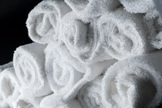Rinse and pat dry with a clean towel.

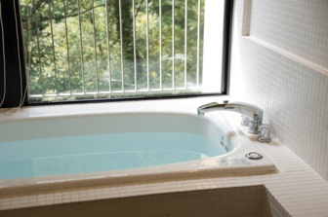If you are using chlorhexidine in a bath, follow the above instructions. Instead of turning off the water and turning it back on, move each body part out of the water in the bath to rub the chlorhexidine into the skin and keep the body part out of the water for two minutes prior to rinsing.

**REFERENCE**

1. *Huang SS, Septimus E, Kleinman K, et al. Chlorhexidine versus routine bathing to prevent multidrug-resistant organisms and all-cause bloodstream infections in general medical and surgical units (ABATE Infection trial): a cluster-randomised trial. Lancet. 2019;393(10177):1205-1215. doi:10.1016/S0140-6736(18)32593-5*

Huang SS, Singh R, McKinnell JA, et al. Decolonization to Reduce Postdischarge Infection Risk among MRSA Carriers. New England Journal of Medicine. 2019;380(7):638-650. doi:10.1056/NEJMoa1716771